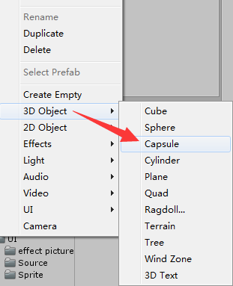

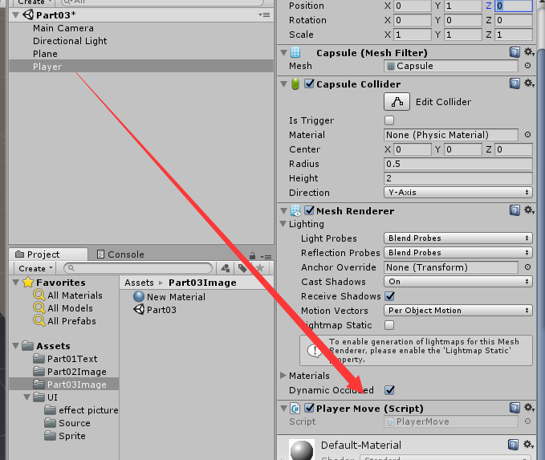

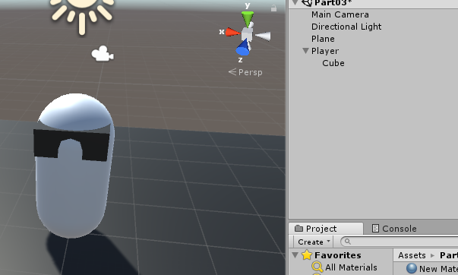

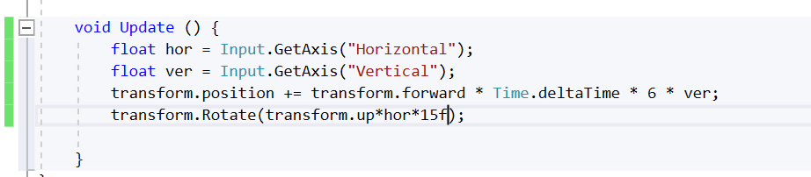

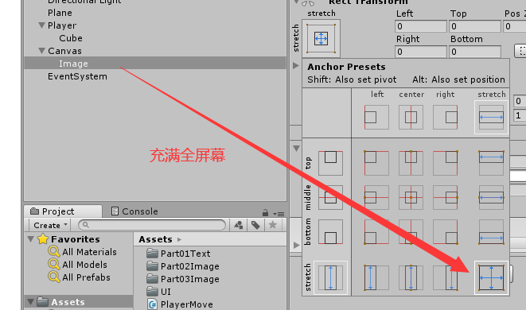



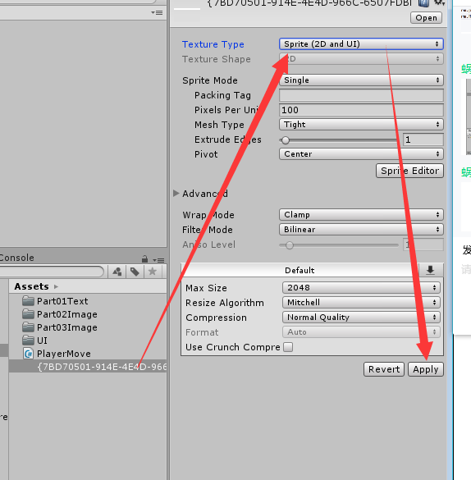

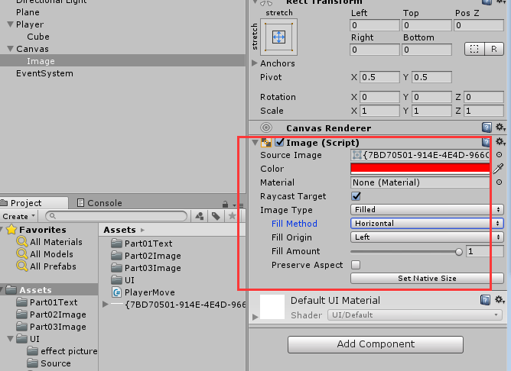

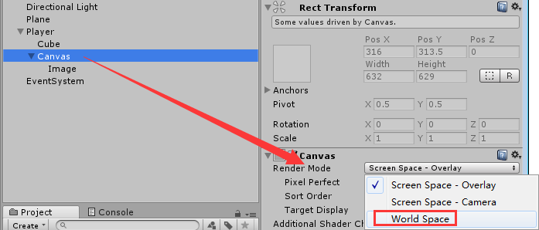

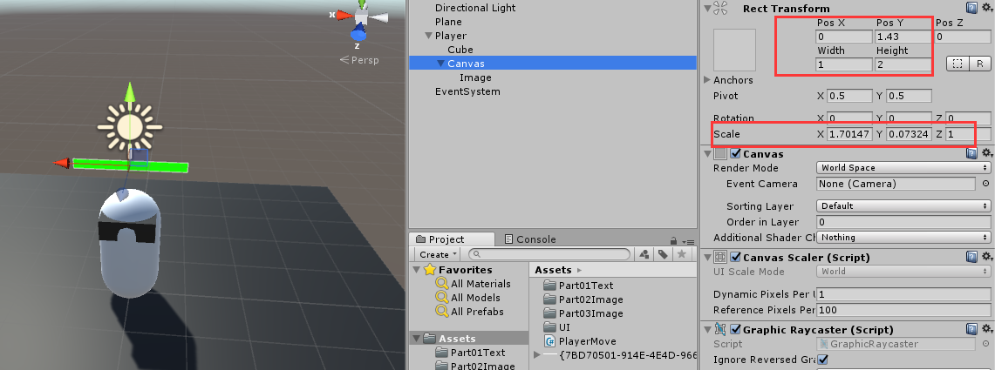

using UnityEngine.UI;

public class PlayerMove : MonoBehaviour

{

Image playerImage;

public float hp = 100;

public float totalhp;

void Start()

{

playerImage = transform.GetChild(0).GetComponent<Image>();

totalhp = hp;

}

void Update()

{

float hor = Input.GetAxis("Horizontal");

float ver = Input.GetAxis("Vertical");

transform.position += transform.forward \* Time.deltaTime \* 6 \* ver;

transform.Rotate(transform.up \* hor \* 15);

if (Input.GetMouseButtonDown(0))

{

TakeDamage(10);

}

}

public void TakeDamage(int val)

{

if (hp <= 0)

{

Destroy(gameObject);

}

hp -= val;

playerImage.fillAmount = hp / totalhp;

if (hp <= 20)

{

playerImage.color = Color.red;

}

}

}